**Name** : Bhavik Ransubhe

**Class** : TE (B) COMP

**ROLL NO**: 39055

**LAB ASSIGNMENT 10 (B4)**

**TCP CHAT SOCKET PROGRAMMING**

**CODE:-**

1)Client1.java (NEW THREAD):-

package com.company;  
  
import java.io.DataInputStream;  
import java.io.DataOutputStream;  
import java.io.IOException;  
import java.net.ServerSocket;  
import java.net.Socket;  
public class Client1 {  
 public static void main(String[] args) throws IOException {  
 ServerSocket ss;  
 Socket s;  
 DataInputStream dis;  
 DataOutputStream dos;  
 int port = 6000;  
 ss = new ServerSocket(port);  
 while (true){  
 try {  
 s = ss.accept();  
 dis = new DataInputStream(s.getInputStream());  
 dos = new DataOutputStream(s.getOutputStream());  
 Thread t = new Chat(s, dis, dos);  
 t.start();  
 if (s.isConnected()) {  
 System.out.println("\n\t\t\t\t\t\tConnection with Client : Success\n");  
 } else {  
 System.out.println("F A I L E D");  
 }  
 } catch (Exception e) {  
 System.out.println("Socket could not be created " + e);  
 }  
 }  
 }  
}

2)Client2.java (NEW THREAD):-

package com.company;  
  
import java.io.DataInputStream;  
import java.io.DataOutputStream;  
import java.io.IOException;  
import java.net.InetAddress;  
import java.net.Socket;  
import java.util.Scanner;  
public class Client2 {  
 public static void main(String[] args) {  
 Socket s = null;  
 InetAddress ip;  
 DataInputStream dis;  
 DataOutputStream dos;  
 int port = 6000;  
 try {  
 ip = InetAddress.getLocalHost();  
 s = new Socket(ip,port);  
 dis = new DataInputStream(s.getInputStream());  
 dos = new DataOutputStream(s.getOutputStream());  
 System.out.println("\n\t\t\t\t\t\tConnection with Client : Success\n");  
 Scanner sc = new Scanner(System.in);  
 System.out.println("*************************** Register *************************");  
 System.out.print("Name : ");  
 String name = sc.nextLine();  
 dos.writeUTF(name);  
 System.out.println("**************************************************************");  
 System.out.println("\n-------------------------Conversation------------------------\n");  
 String otherClientName = dis.readUTF();  
 while (true) {  
 String send;  
 String receive;  
 receive = dis.readUTF();  
 if(receive.toLowerCase().contains("bye"))  
 {  
 System.out.println(otherClientName + "; says bye!");  
 s.close();  
 System.out.println("\n-------------------------------------------------------------\n");  
 break;  
 }  
 System.out.println(otherClientName + " : " + receive);  
 System.out.print(name + " : ");  
 send = sc.nextLine();  
 if(send.toLowerCase().contains("bye"))  
 {  
 dos.writeUTF(otherClientName + " : " + send);  
 s.close();  
 System.out.println("\n-------------------------------------------------------------\n");  
 break;  
 }  
 dos.writeUTF(send);  
 }  
 } catch (IOException e) {  
 e.printStackTrace();  
 }  
 }  
}

3)Chat.java (extending THREAD and implementing @Override run()):-

package com.company;  
  
import java.io.DataInputStream;  
import java.io.DataOutputStream;  
import java.io.IOException;  
import java.net.Socket;  
import java.util.Scanner;  
public class Chat extends Thread{  
 final DataInputStream dis;  
 final DataOutputStream dos;  
 final Socket s;  
 public Chat(Socket s, DataInputStream dis, DataOutputStream dos) {  
 this.s = s;  
 this.dis = dis;  
 this.dos = dos;  
 }  
 @Override  
 public void run() {  
 Scanner sc = new Scanner(System.in);  
 System.out.println("*************************** Register *************************");  
 System.out.print("Name : ");  
 String name = sc.nextLine();  
 try {  
 dos.writeUTF(name);  
 } catch (IOException e) {  
 e.printStackTrace();  
 }  
 System.out.println("**************************************************************");  
 String otherClientName = null;  
 try {  
 otherClientName = dis.readUTF();  
 } catch (IOException e) {  
 e.printStackTrace();  
 }  
 System.out.println("\n-------------------------Conversation------------------------\n");  
 while(true) {  
 try {  
 String send;  
 String receive;  
 System.out.print(name + " : ");  
 send = sc.nextLine();  
 if(send.toLowerCase().contains("bye"))  
 {  
 dos.writeUTF(otherClientName + " : " + send);  
 System.out.println("\n-------------------------------------------------------------\n");  
 break;  
 }  
 dos.writeUTF(send);  
 receive = dis.readUTF();  
 if(receive.toLowerCase().contains("bye"))  
 {  
 System.out.println(otherClientName + "; says bye!");  
 System.out.println("\n-------------------------------------------------------------\n");  
 break;  
 }  
 System.out.println(otherClientName + " : " + receive);  
 } catch (IOException e) {  
 e.printStackTrace();  
 }  
 }  
 }  
}

**OUTPUT:-**

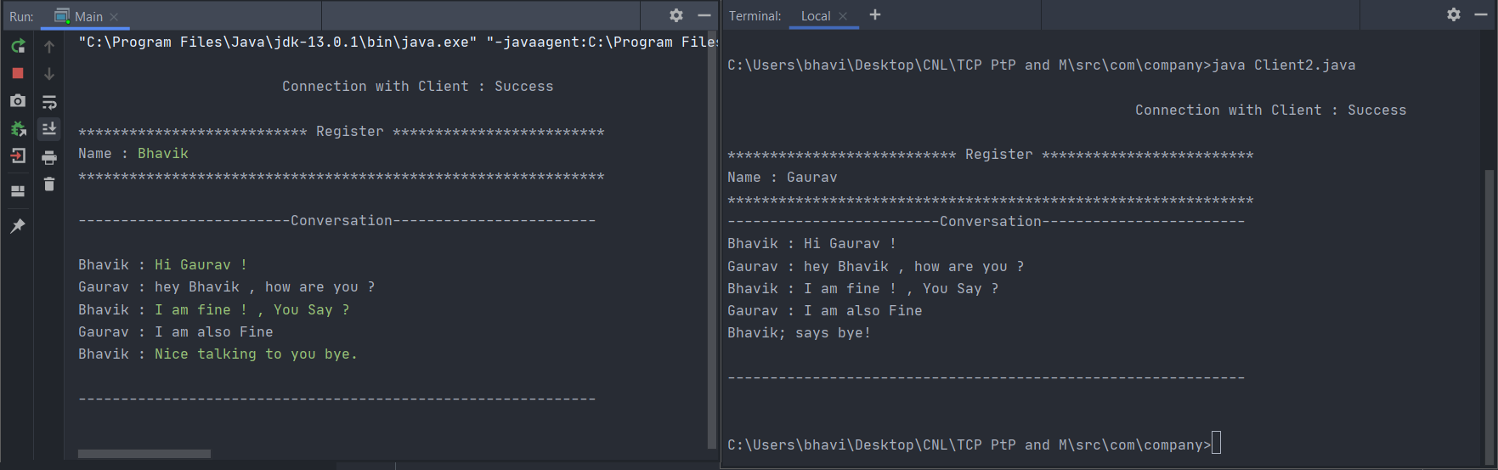

**WIRESHARK:-**



